**Project Development Phase Sprint IV**

|  |  |
| --- | --- |
| Date | 14 November 2022 |
| Team ID | PNT2022TMID40718 |
| Project Name | Project - Signs with smart connectivity for better road safety |

# Code for print the random temperature, Road signs, Speed limit, Message :

**( RandomValues.py )**

import wiotp.sdk.device import time

import random

import ibmiotf.application import ibmiotf.device import requests, json

myConfig = {

#Configuration "identity": {

"orgId": "n6rl9n",

"typeId": "NodeMCU", "deviceId":"621319106312"

},

#API Key

"auth": {

"token": "9876543210"

}

}

#Receiving callbacks from IBM IOT platform def myCommandCallback(cmd):

print("Message received from IBM IoT Platform: %s" % cmd.data['command']) m=cmd.data['command']

client = wiotp.sdk.device.DeviceClient(config=myConfig, logHandlers=None) client.connect()

#OpenWeatherMap Credentials

BASE_URL = "https://api.openweathermap.org/data/2.5/weather?" CITY = "Salem, IN"

URL = BASE_URL + "q=" + CITY + "&units=metric"+"&appid=" + "f58e4720c739a54c439aba9b05176839"

while True:

response = requests.get(URL) if response.status_code == 200: data = response.json()

main = data['main'] temperature = main['temp'] humidity = main['humidity'] pressure = main['pressure'] report = data['visibility']

#messge part msg=random.randint(0,5) if msg==1:

message="GO SLOW, SCHOOL ZONE AHEAD"

elif msg==2:

message="NEED HELP, POLICE STATION AHEAD"

elif msg==3:

message="EMERGENCY, HOSPITAL NEARBY"

elif msg==4:

message="DINE IN, RESTAURENT AVAILABLE"

elif msg==5:

message="PETROL BUNK NEARBY"

else:

message=""

#Speed Limit part speed=random.randint(0,150) if speed>=100:

speedMsg=" Limit Exceeded" elif speed>=60 and speed<100:

speedMsg="Moderate" else:

speedMsg="Slow"

#Diversion part sign=random.randint(0,5) if sign==1:

signMsg="Right Diversion" elif sign==2:

signMsg="Speed Breaker" elif sign==3:

signMsg="Left Diversion" elif sign==4:

signmsg="U Turn" else:

signMsg=""

#Visibility

if temperature < 24:

visibility="Fog Ahead, Drive Slow" elif temperature < 20:

visibility="Bad Weather" else:

visibility="Clear Weather"

else:

print("Error in the HTTP request")

myData={'Temperature':temperature, 'Message':message, 'Sign':signMsg, 'Speed':speedMsg, 'Visibility':visibility}

client.publishEvent(eventId="status", msgFormat="json", data=myData, qos=0, onPublish=None) #PUBLISHING TO IOT WATSON

print("Published data Successfully: ", myData)

print("

") client.commandCallback = myCommandCallback time.sleep(5)

client.disconnect()

# Python Simulation :

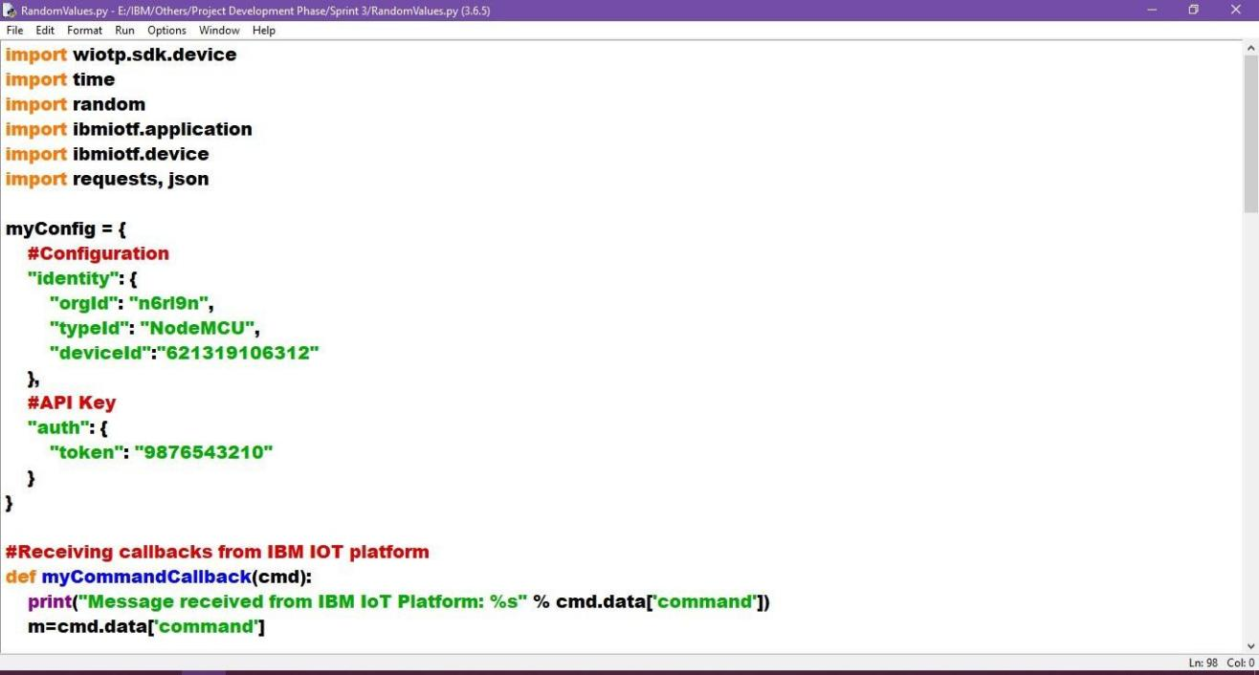

**Import wiotp-sdk & ibmiotf :**

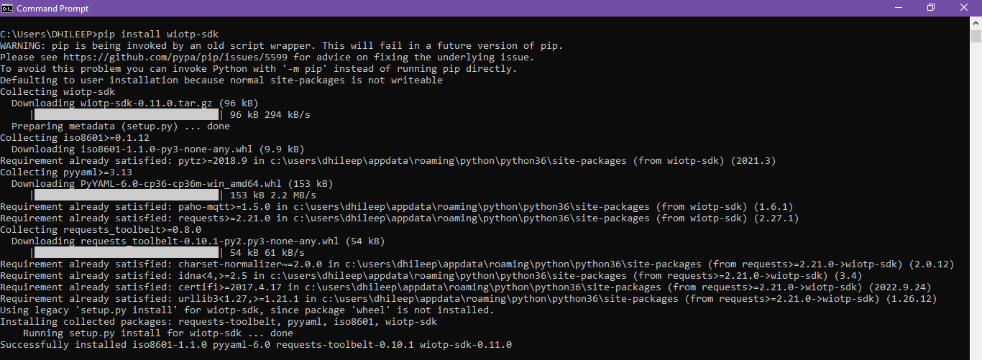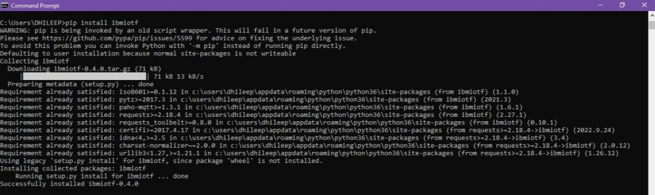

# OpenWeatherMap - (Ex., Salem, IN) :

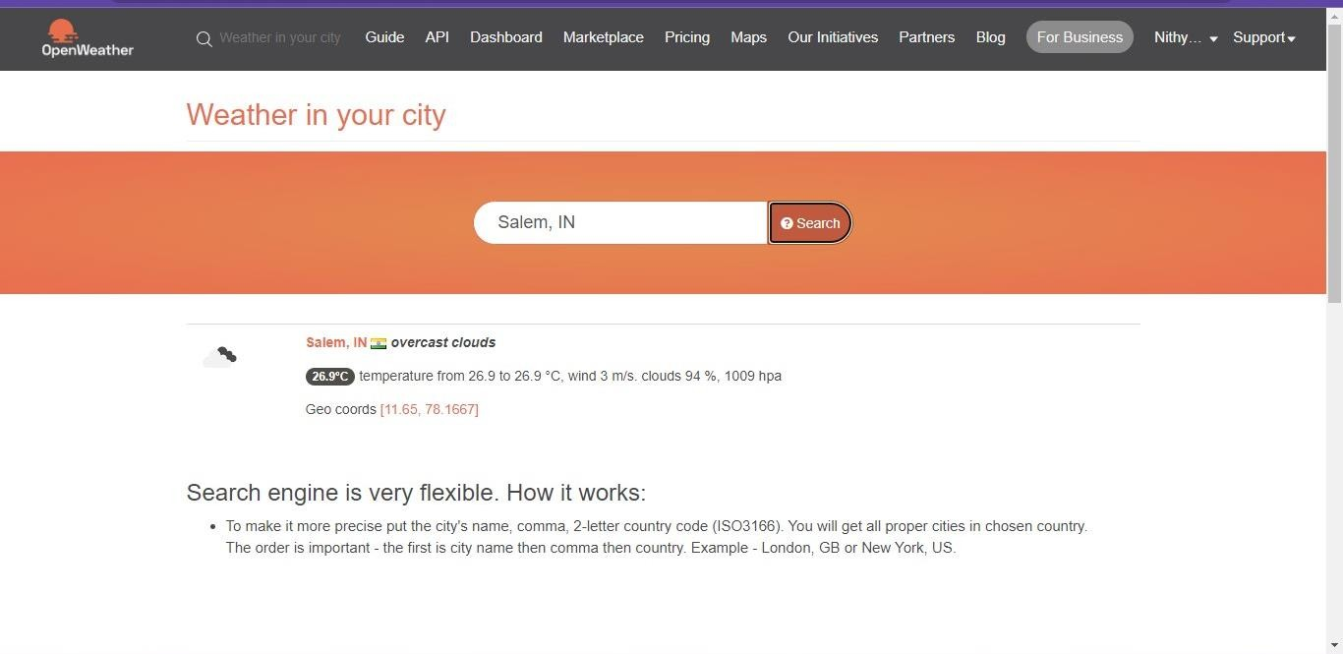

**Python IDLE Output :**

